**Research and Publication Opportunities in Health-IS: A 2012 Update**

E. Vance Wilson, Ph.D. (vancewilson@gmail.com)

Health-IS Professional Development Workshop sponsored by AIS SIG-Health

August 9, 2012, Seattle, WA

1. **“Health-IS”** – A label I’ve come to apply to IS researchers and practitioners working in healthcare contexts; the name is based on the academic origins of the participants
2. **The Situation in 2004** (based on my tutorial presentation at the 2004 America’s Conference on Information Systems in New York City)
   1. **Why Focus on IS and Healthcare?**
      1. Healthcare is a massive industry: 14% of US GDP in 2000; 16% projected by 2010 ($2.6 Trillion) ***Update*** *$2.6 Trillion is correct, but 17.9% of GDP due to recession*
      2. Health IT is undergoing major transformations due to
         * HIPAA and other regulations ***Update*** *True! Now including the Patient Protection and Affordable Care Act of 2010*
         * Acquisitions and mergers ***Update*** *True! The top 10 hospital mergers and acquisitions of 2010 were valued at $3.8 billion*
         * Increasing consumerism as patients pay more of their own bills and become more informed via online sources (i.e., e-health) ***Update*** *Increasing, but slower than I expected in 2004*
      3. High need for expertise: IS researchers have dealt with transformations in other fields similar to those that Health Informatics (HI) researchers are beginning to confront ***Update*** *Health IT reported in 2011 as #1 on top 10 ‘hot’ careers list*
      4. Significant opportunities for research funding ***Update*** *True! Federal grant opportunities have increased substantially for IS researchers*
   2. **Recommended Publication Strategies (see Figure 1)**
      1. Journal editors and reviewers function as gatekeepers guarding admission to their domain ***Update*** *Remains true*
      2. Principles drawn from the “local” discipline are presumed sound, others may require justification ***Update*** *Also remains true*
      3. 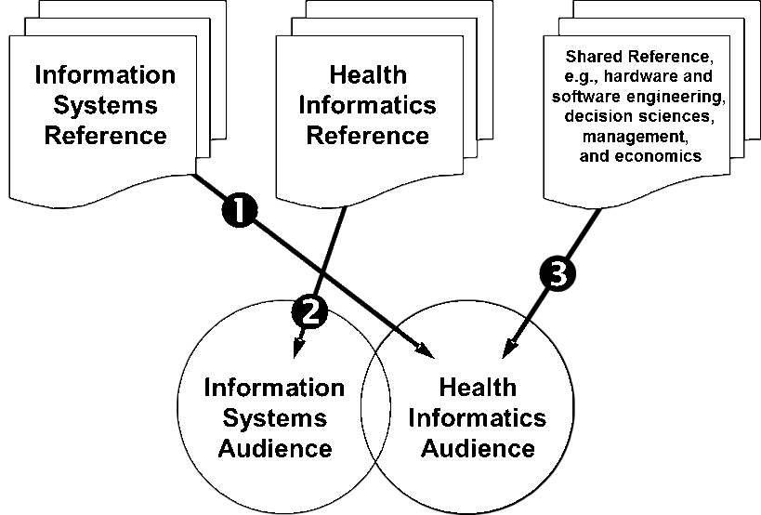Manuscripts that fail to pique reviewers’ interest typically are rejected ***Update*** *Remains true, but with the upside that IS reviewers and editors are increasingly interested in health-IS papers*

Figure 1: Three publication strategies I recommended in 2004 as a means to work around resistance to health-IS papers by mainstream IS journals and to thereby improve P&T prospects for health-IS researchers; note that my only recommendation involving IS audiences at the time was to write about health informatics as an “informing” discipline.

* 1. **The “Bad News” in 2004**
     1. “No recommended strategy was found for publishing papers in the overlap between IS and health informatics audiences shown in Figure 1. Up to this point, no journal outlet is directed toward an interdisciplinary IS and health informatics audience, although tracks with this focus emerged at major IS conferences, including HICSS, AMCIS, and IRMA.” ***Update*** *Along with regular special issues promoted by SIG-Health, two major journal outlets now exist: the Information Systems and Healthcare Department at Communications of the AIS and Palgrave’s Health Systems.*
     2. “Little consensus exists across academic institutions on how health informatics journal publications should be rated.” ***Update*** *Remains true*
     3. Chaisson & Davidson (2004) “Pushing the Contextual Envelope: Developing and Diffusing IS Theory for Health Information Systems Research”, *Information and Organization* – analyzed the contents of representative peer-reviewed IT and allied journals between the years of 1985 and mid-2003; although the health care sector accounted for up to 14% of GDP in developed nations during that period, Chaisson and Davidson found that only 1.2% of articles published in the IT journals addressed any aspect of health care. ***Update*** *The situation has improved substantially…*

1. **Transitional Years: 2004-2012** 
   1. **A trajectory of improving opportunity**
      1. Wilson & Tulu (2010) “The Rise of a Health-IT Academic Focus”, *CACM* – updated the Chaisson & Davidson study, finding that through 2009 the percentage of health-related articles in mainstream IS journals had nearly doubled (see Figure 2)

Figure 2. Trajectory of health-related publications in mainstream IS journals

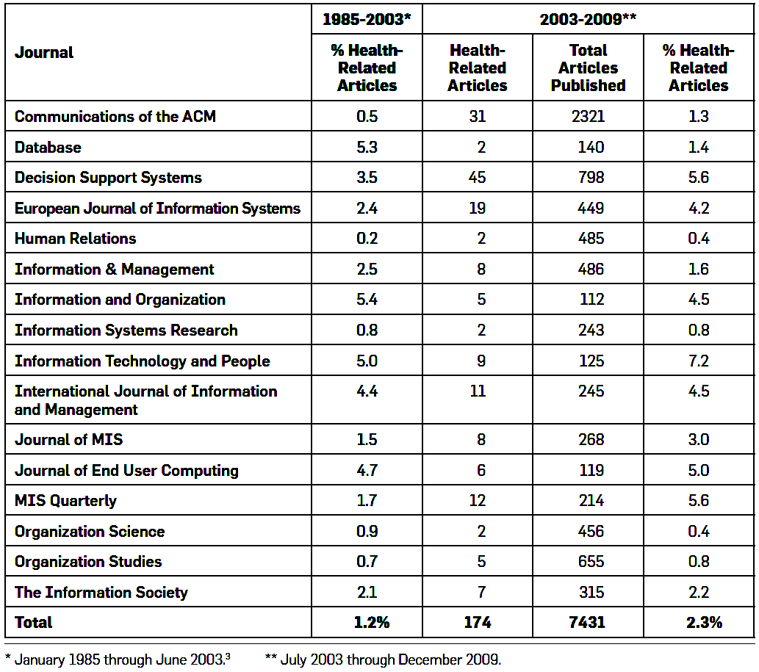

* 1. **Conference Tracks**
     1. HICSS, IT in healthcare track beginning in 1999
     2. AMCIS, IT in healthcare mini-tracks beginning in 2003
     3. ECIS, healthcare mini-tracks beginning in 2005 (intermittent since then)
     4. ICIS, healthcare track beginning in 2010
     5. PACIS, IS/IT in healthcare track beginning in 2010
  2. **Selected Special Issues/Sections in IS Journals**
     1. *Information Systems Management,* “IT in Healthcare”, 2007
     2. *Decision Support Systems,* “Decision Support in Medicine”, 2007
     3. *e-Service Journal,* “Research in e-Health” and “Practice and Outlook in e-Health”, 2007
     4. *European Journal of Information Systems,* “Health Information Systems Research, Revelations and Visions”, 2007
     5. *Journal of the AIS,* “Health Care IT”, 2011
     6. *Information Systems Research,* “The Role of Information Systems in Healthcare”, 2011
     7. *Communications of the AIS,* “Patient-Centered E-Health”, manuscripts due October 2012
     8. *Electronic Commerce Research and Applications,* “eHealth and Healthcare Service Transformation”, manuscripts due March 2013
  3. **IS Journals focusing on health-IS** (not included in analysis by Wilson & Tulu, 2010)
     1. *Communications of the AIS* Information Systems and Healthcare Department, inaugurated in 2004
        + Invites submissions supporting health-IS research as well as traditional research studies
        + 43 articles published to date
     2. *Health Systems,* inaugurated in 2012
        + Interdisciplinary with primary focus on OR and IS health-related research
        + IS submissions edited by Cindy LeRouge and Fay Cobb Payton
        + 9 articles published to date



Figure 3: I now recommend that health-IS researchers apply a primary strategy of writing for IS audiences in order to support P&T efforts. There continue to be benefits in bringing IS and reference discipline theories and methods to health informatics audiences as a secondary publication strategy if the local P&T practices support this approach.

1. **What’s New in 2012**
   1. **Recommended Publication Strategies** (see Figure 3)
      1. Primary strategy: Publish health-IS research to an IS audience which is increasingly interested in health-related topics, including top-tier IS journals
      2. Secondary strategy: Target “selected” health informatics conferences and journals to reach health informatics audiences; SIG-Health members have been well accepted at AMIA conferences and in top-tier health informatics journals, e.g., *JAMIA* and *IJMI*
   2. **What we have enough of:**
      1. Conceptual frameworks for study of health-IS topics; it is now time to do rather than plan to do
   3. **What we need more of:**
      1. Theory-building

* Application of IS theories to explain and predict health-IS outcomes
  + Example: Klein (2007) “An Empirical Examination of Patient-Physician Portal Acceptance”, *EJIS*; applied the technology acceptance model (TAM)
* Customization of IS theories to explain and predict health-IS outcomes
  + Example: Wilson & Lankton (2009) “Predicting Patients’ Use of Provider-Delivered E-Health: The Role of Facilitating Conditions”, chapter in *Patient-Centered E-Health;* extended TAM with proxy measures of FC
    1. Development of Validated Research Tools (note lack of examples!)
       - Instruments and measures
       - Methods and protocols, e.g., for collecting data via mobile devices
    2. Economic impact studies
       - Example: Medaglia & Andersen (2010) “Virus Outbreak—Online GP Consultations Escalating Healthcare Costs”, *CAIS;* predicts rising costs of e-health
    3. Policy research from health-IS perspectives
       - Example: Chatterjee, LeRouge, & Tremblay (Forthcoming) “Educating Students in Health Information Technology: IS Community Barriers, Challenges and Paths Forward”, *CAIS;* examines healthcare IT education practices and suggests strategies for developing HIT curricula for IS students