
New AIS SIG/Chapter/College Annual Report Form Information
Welcome to the new form!
Anytime something changes people often ask “why?” The simple answer is we want to better evaluate the health of and better recognize the work of AIS SIGs/Chapters/Colleges. There are the normal “house keeping” types of things that we need to track, but we truly want to know how your group is making a difference for fellow members and the IS field in general. As time goes on we will evaluate the form and the information it gathers and work to improve it.

Dual Purpose Form
Here is the good news…this form serves two purposes! Not only is it your annual report form, but it is also your application for Outstanding SIG/Chapter/College.

The Annual Report form, due by February 15, 2015 serves as your group’s application for Outstanding SIG/Chapter/College. Annual Reports cover a calendar year (January through December); all activities meeting the recognition criteria must have occurred during the reported time period.

Outstanding SIG/Chapter

The Outstanding SIG/Chapter/College designation honors all SIGs/Chapters/Colleges that meet the minimum standards that all groups should strive to meet and exceed. This recognition will serve as motivation to maintain operations, programs, and services of a successful SIG/Chapter/College.

All SIGs/Chapters/Colleges that meet the criteria will receive recognition. A SIG/Chapter/College is eligible to
receive recognition every year they meet the criteria. To be recognized as an Outstanding SIG/Chapter/College, a SIG/Chapter/College must meet the criteria in a single calendar year.

An outline to help determine whether a SIG/Chapter/College has met the criteria is provided below. The actual form is below and can be submitted electronically. While it is a PDF, you will notice a submit button at the bottom of the last page. You can save your progress as you go along, but we strongly recommend completing the form in one setting. This form should take, at most, an hour to complete.

Cultural Differences Among SIGs/Chapters/Colleges

AIS understands that SIGs/Chapters/Colleges may have different fiscal years and Annual General Meeting (AGM) dates. We are a global society. We ask that every chapter and SIG fill out this form and report activities for a calendar year from January 1 to December 31. The deadline for completing and returning this form to AIS is February 15, 2015. The criteria have been designed to be fair to all SIGs /Chapters/Colleges.

SIGs, Chapters, and Colleges elect officers during different times of the year. For the purposes of this recognition program, we are requesting information from all SIGs, Chapters, and Colleges about officer positions on December 31 of the reporting year no matter when your elections take place.


SIG/Chapter/College Annual Report Form

Overview

This program is designed to recognize SIGs/Chapters/Colleges that do an outstanding job of supporting the mission of AIS through the advancement of knowledge and the promotion of excellence in the practice and study of information systems.

SIGs/Chapters/Colleges will be evaluated by an AIS committee consisting of academic members who have an interest in SIGs, Chapters and Colleges and will also be approved by the VP for SIGs, Chapters, and Colleges for this recognition based upon this form and attached documentation. Outstanding SIGs/Chapters/Colleges will be recognized each year at the International Conference on Information Systems (ICIS) and/or the Americas Conference on Information Systems (AMCIS). Recognition will also be given in appropriate AIS electronic publications.

Annual Report & Recognition Form
(Form will be submitted online; this template is intended to help you prepare the necessary information.)

Group Type: ☐ Chapter X SIG ☐ College Name of Group: SIGHealth

Officer submitting the report: Gondy Leroy Officer Title: President

Officer Email Address: gondyleroy@email.arizona.edu Group Website: http://www.aissighealth.com

Did your group’s bylaws change within the reporting year? ☐ Yes X No
If changed, have your new bylaws been submitted to AIS (sigschapters@aisnet.org)? ☐ Yes ☐ No

(Chapters Only) Does your chapter collect dues? X Yes ☐ No
If yes, list the dues amount $10.00 per year and currency in which it is collected: US Dollars

Required Criteria The SIG/Chapter/College has …
1. Hosted one activity, meeting, or event that is open to all AIS members. |  |  |  |  | X Yes ☐ No |  | Required
2. Conducted one Annual General Meeting (AGM). |  |  |  |  | X Yes ☐ No |  | Required
3. Conducted at least one Executive Board meeting. |  |  |  |  | X Yes ☐ No |  | Required
4. Submitted the Annual Report on or before February 15. |  |  |  |  | X Yes ☐ No |  | Required
5. All officer positions listed in the group bylaws are filled on December 31 of this reporting period.  (Please see your bylaws for the list of officer positions. They often include the roles of: President, President-Elect, Secretary, and Treasurer) |  |  |  |  | X Yes ☐ No |  | Required
Officer Title (Please see your group bylaws for a list of your officers) |  |  |  | Approx. date they took office MM/YY |  | Approx. date of next election for position  MM/YY
 | Officer Title | Name | Email Address
Ex. | President | Jim Jones | jj@email.com | 06/14 |  | 06/16
1. | President | Gondy Leroy | gondyleroy@email.arizona.edu | 09/14 |  | 09/16
2. | Immediate Past President | Vance Wilson | vancewilson@gmail.com | 09/14 |  | 09/16
3. | President-elect | Surendra Sarnikar | surendra.sarnikar@dsu.edu | 09/14 |  | 09/16
4. | Secretary | Renée Pratt | rpratt@isenberg.umass.edu | 09/15 |  | 09/17
5. | Treasurer | Kaushik Ghosh | kghosh@lamar.edu | 09/14 |  | 09/16

For the purpose of the Annual Report, please complete as much of the following information as possible.
To be considered for Outstanding SIG or Chapter recognition, a total of 100 points must be earned from the following five categories.

Additional Criteria (In addition to the required elements listed above, a total of 100 points must be earned from the following five categories) | Value | Category  Maximum

A. Organized and ran a track or workshop at an AIS or AIS affiliated conference or hosted a webinar, seminar, or other conference. Do not list the Annual General Meeting here. |  |  | 15 points per event | 60 points
Name of Conference |  | Title of Track/Webinar/Workshop |  | MM/DD/YY
Example: 8th International Research Workshop on IT Project Management |  | IT Project Management |  | 11/11/14
1. | INFORMS Healthcare 2015, July 29 – 31, 2015 Nashville, TN: 30pts, 2 tracks | Track 1: IS&T for improving the healthcare process and system and  Track 2: IS&T for improving individuals’  interactions with the healthcare system  http://meetings2.informs.org/wordpress/healthcare2015/cluster-chairs/ |  | 07/29/15
2. | Association for Information Systems Conference, August 13 - 15, 2014 San Juan, PR | Innovations in Healthcare Information Systems Track (SIGHealth) |  | 08/14/15
3. | International Conference on Information Systems, December 13-16, Fort Worth, TX | IS in Healthcare |  | 12/14/15

B. Published one or more academic journal issues or special research topic issues.  (Publication date should be in the calendar year of the Annual Report.) |  |  | 15 points per publication | 0 points
Name of Journal |  | Title of Specific Issue |  | MM/DD/YY
Example: THCI |  | HCI Designs and Innovations in Social Media |  | 06/01/14
1. | Journal of Information Technology and Development  (papers due in November, publication in 2016): 0 points | Special Issue on Healthcare Information Technology for Development: Improvements in people’s lives through innovations in the uses of technologies.
2.
3.
4.

C. Developed SIG/Chapter award and recognition programs presented annually to members (types of awards are best track papers, volunteer of the year, and best reviewer). |  |  | 5 points per award or recognition granted | 15 points
Type of Award |  | Awardee Name |  | MM/DD/YY
Example: Best paper in Track |  | Henry Wallace |  | 08/09/14
1. | Best Student Paper Award – at AMCIS | Pasi Karppinen, Tuomas Lehto, Harri Oinas-Kukkonen (University of Oulu), Timo Pätiälä, Osmo Saarelma (Duodecim Medical Publications Ltd.) |  | 08/14/15
2. | Best Paper Award – at AMCIS | Jim Ryan (Troy University, Phenix City and Auburn University Montgomery), Barbara Doster, Sandra Daily (University of Alabama at Birmingham Hospital), Carmen Lewis (Troy University, Phenix City) |  | 08/14/2015
3. | Meritorious Mentions – at AMCIS | Diane Strong (Worcester Polytechnic Institute), Olga Volkoff (Simon Fraser University), Sharon A. Johnson (Worcester Polytechnic Institute), Lori R. Pelletier (UMass Memorial Healthcare), Bengisu Tulu (Worcester Polytechnic Institute), Isa Bar-On (Worcester Polytechnic Institute), John Trudel, Lawrence Garber (Reliant Medical Group) |  | 08/14/2015
4.

D. Communicated with all members and other interested individuals to promote the activities of the SIG/Chapter/College through broadcast push messages. Communications can occur in any medium determined to be effective for your group; examples include newsletters, listserv announcements, or social media posts. They all can be in one medium. Please send a copy of the communication(s), screen shots are acceptable, to sigschapters@aisnet.org (subject: Annual report communications). |  |  | 5 points per promotional communication | 265 points
Medium (Type of push message) |  | Subject Line of Message |  | MM/DD/YY
Example: AIS Listserv |  | Upcoming SIGGIS workshop ICIS Ft. Worth |  | 06/27/14
1. | SIGHealth News Letter (January): 5 pts | SIGHealth News Letter |  | 01/15
2. | SIGHealth News Letter (May) : 5 pts | SIGHealth News Letter |  | 05/15
3. | SIGHealth News Letter (July) : 5 pts | SIGHealth News Letter |  | 07/15
4. | Twitter – 4 tweets: 20 pts | https://twitter.com/aissighealth |  | 2015
5. | Facebook, newly created in 2015. – 25 posts : 125 pts | https://www.facebook.com/AIS.SIGHealth |  | 2015
6. | LinkedIn – 9 posts: 45 pts | https://www.linkedin.com/company/ais-sighealth |  | 2015
7. | AIS Listserve – CFP INFORMS Healthcare 2015, ICIS, AMCIS Best Paper(2xs) AMCIS Tracks, ICIS (2xs): 25 pts | CFP – INFORMS health care 1/6/15  AMCIS: Best Published Paper Award AIS SIG-Health 5/16/2015  AMCIS: SIGHealth Meeting Reminder 8/12/15  AMCIS2016 Healthcare Informatics and Information Technology Track Call for Mini-track Proposals 9/7/15  ICIS: SIG Health Business Meeting 10/2/15 |  | 2015
8. | SIG Listserve – Newly created in 2015. Seven discussion threads in 2015 (2 in 2016) with 26 posts in total. 35 points if we count ONLY the threads: 35 pts | A variety of messages |  | 2015

E. Updated the SIG/Chapter Website within the past calendar year. (Send a screenshot to sigschapters@aisnet.org).  X Yes ☐ No | 10 points | 10 points

F. Revitalized the SIG/Chapter/College with a change in Executive Leadership  (According to the AIS Bylaws, Section 8.4 Organization. The terms of subdivision officers may be no more than three years.) Points will be awarded for each appropriate officer turnover listed in #5 above. | 5 points for each position that has a new officer in place after three years | 5 points
New Secretary |  | 5  5

Additional Notes:
- Three 2015 Newsletters Attached in PDF Format.
- LinkedIn Page
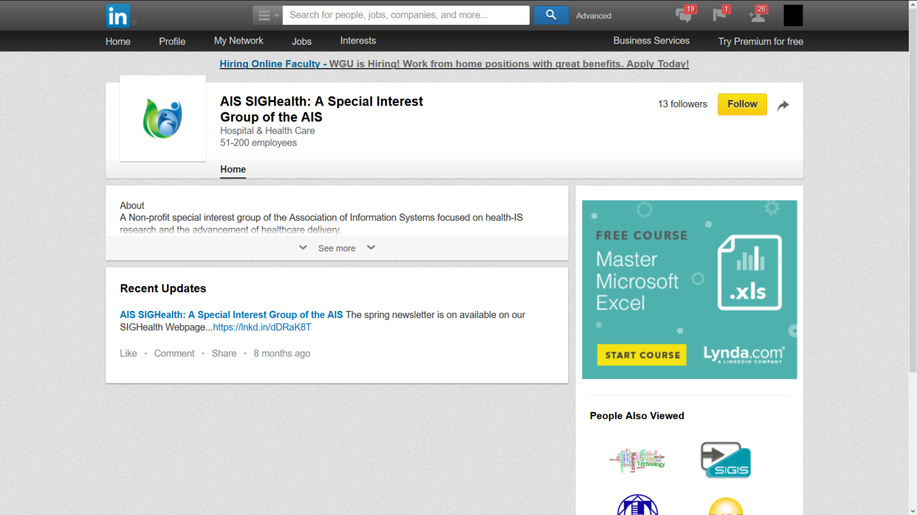
- Facebook page

- Twitter
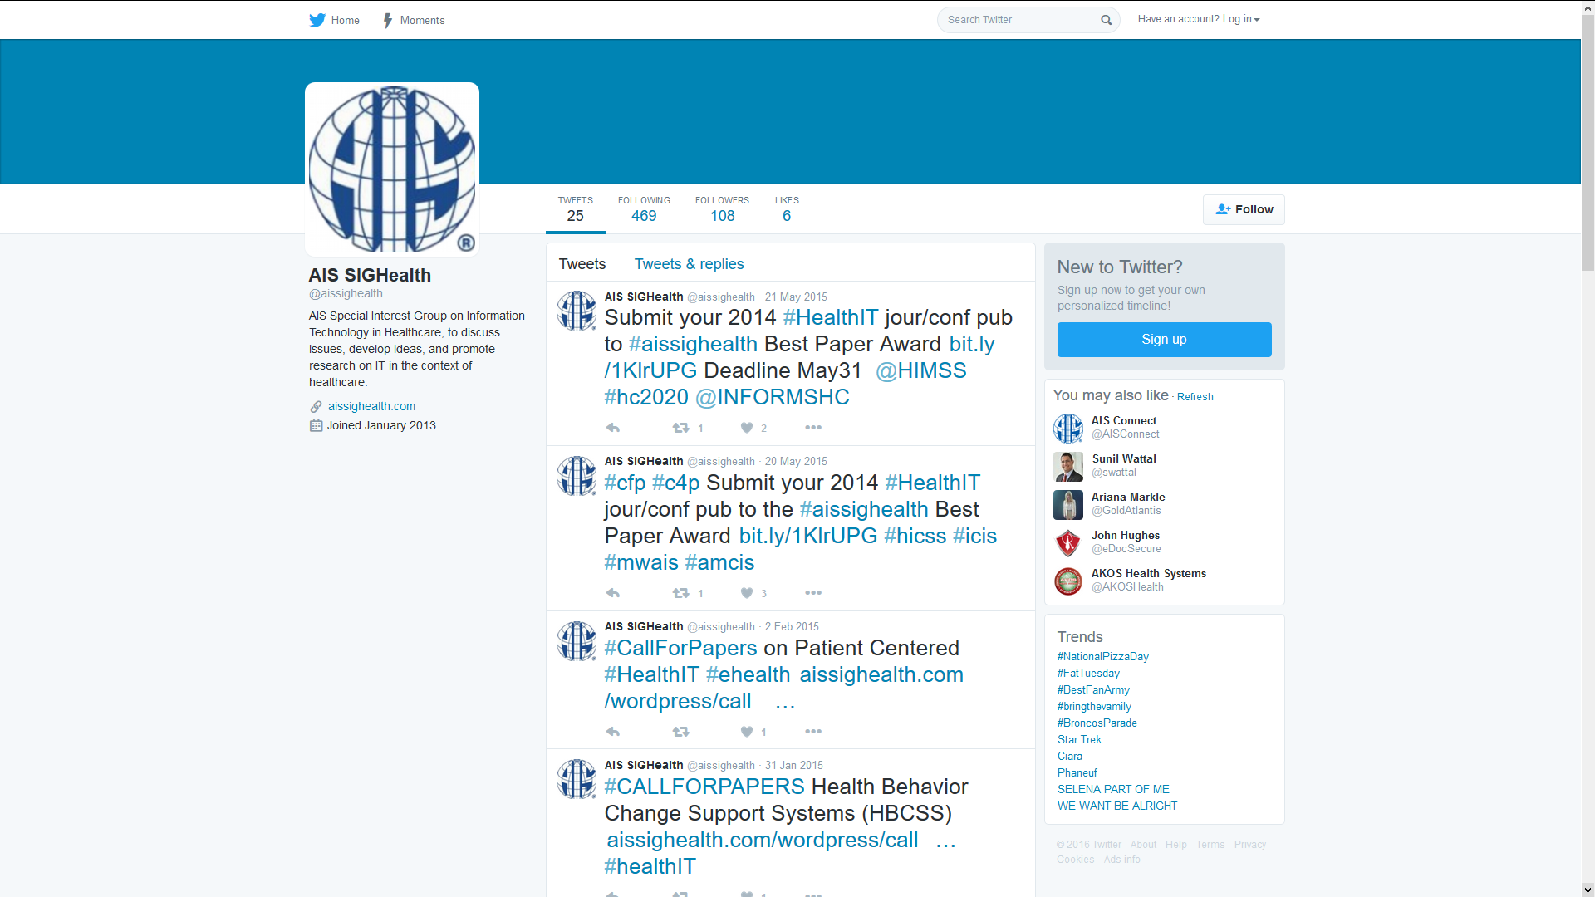
- Current Web Page
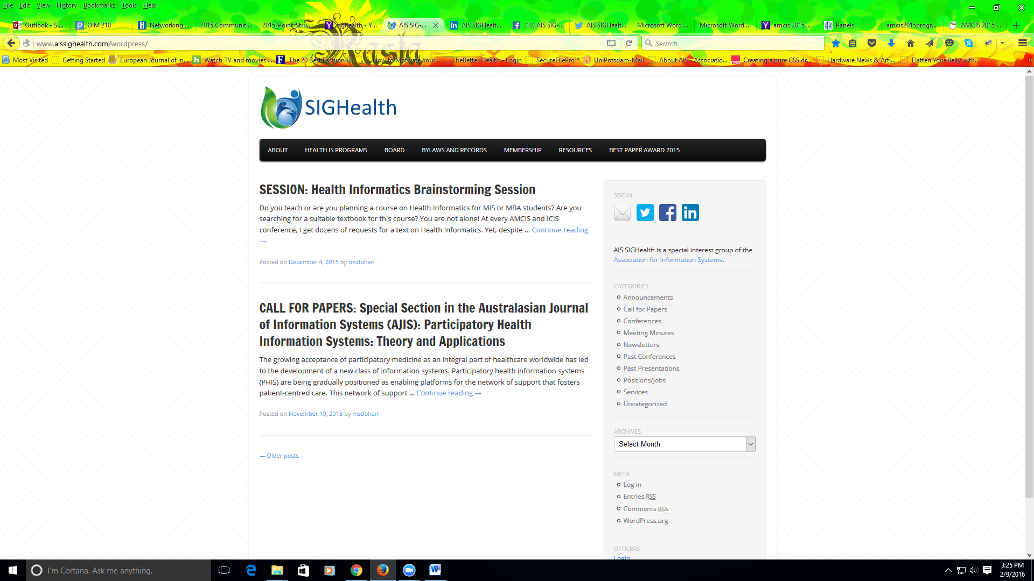

- 2015 Posts on Facebook:

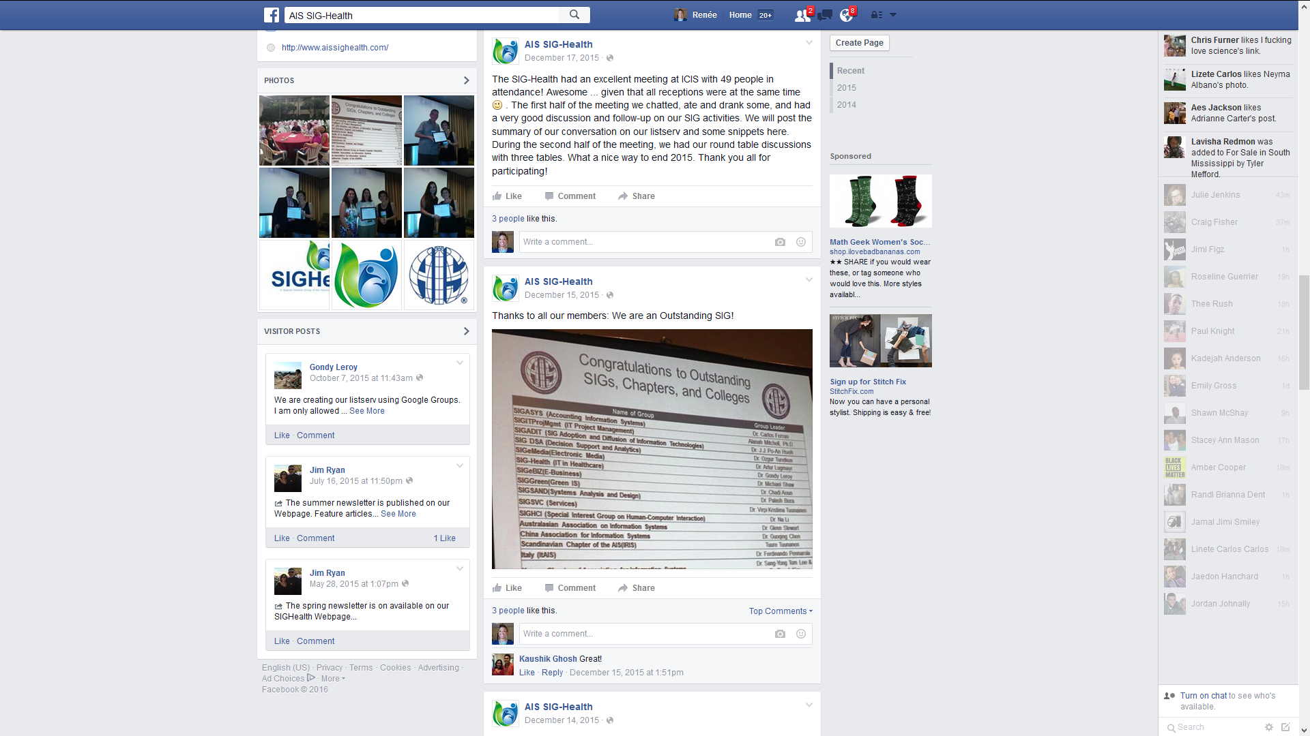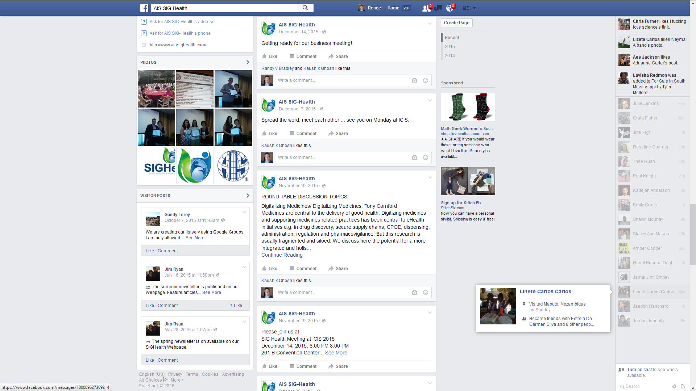
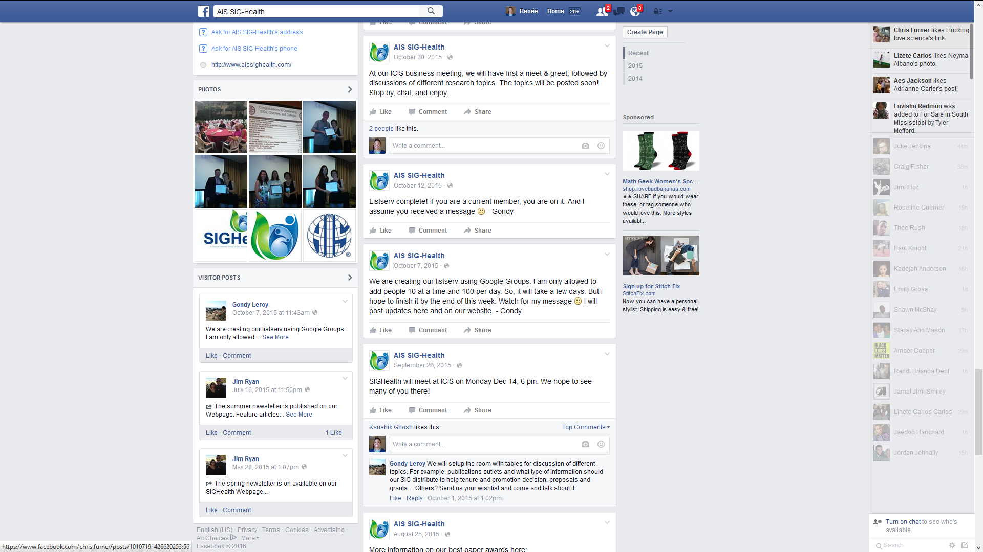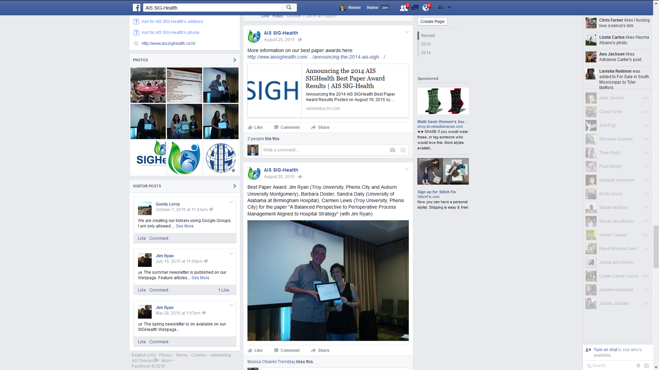
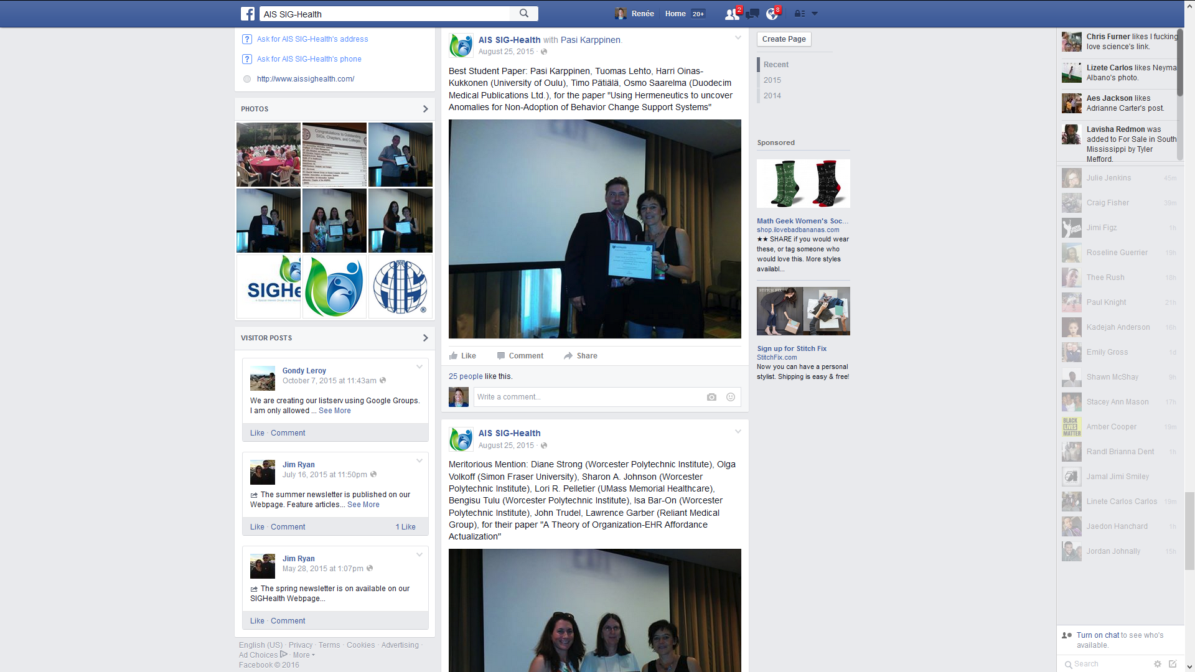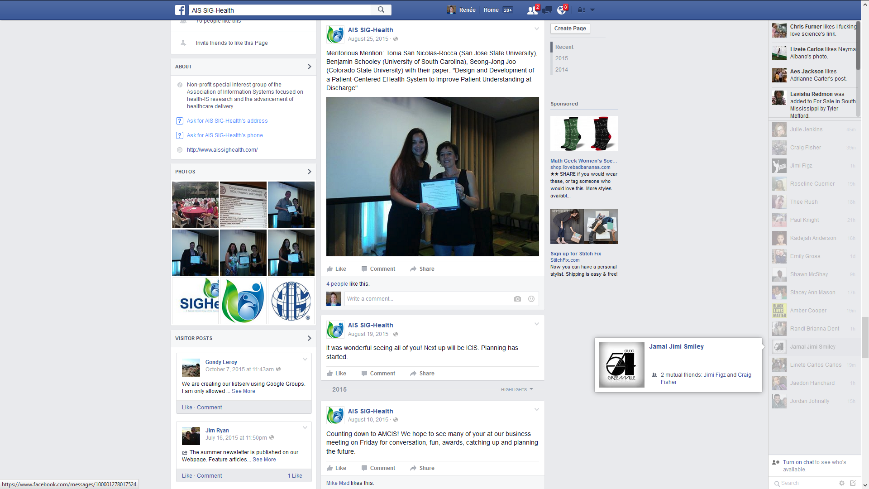

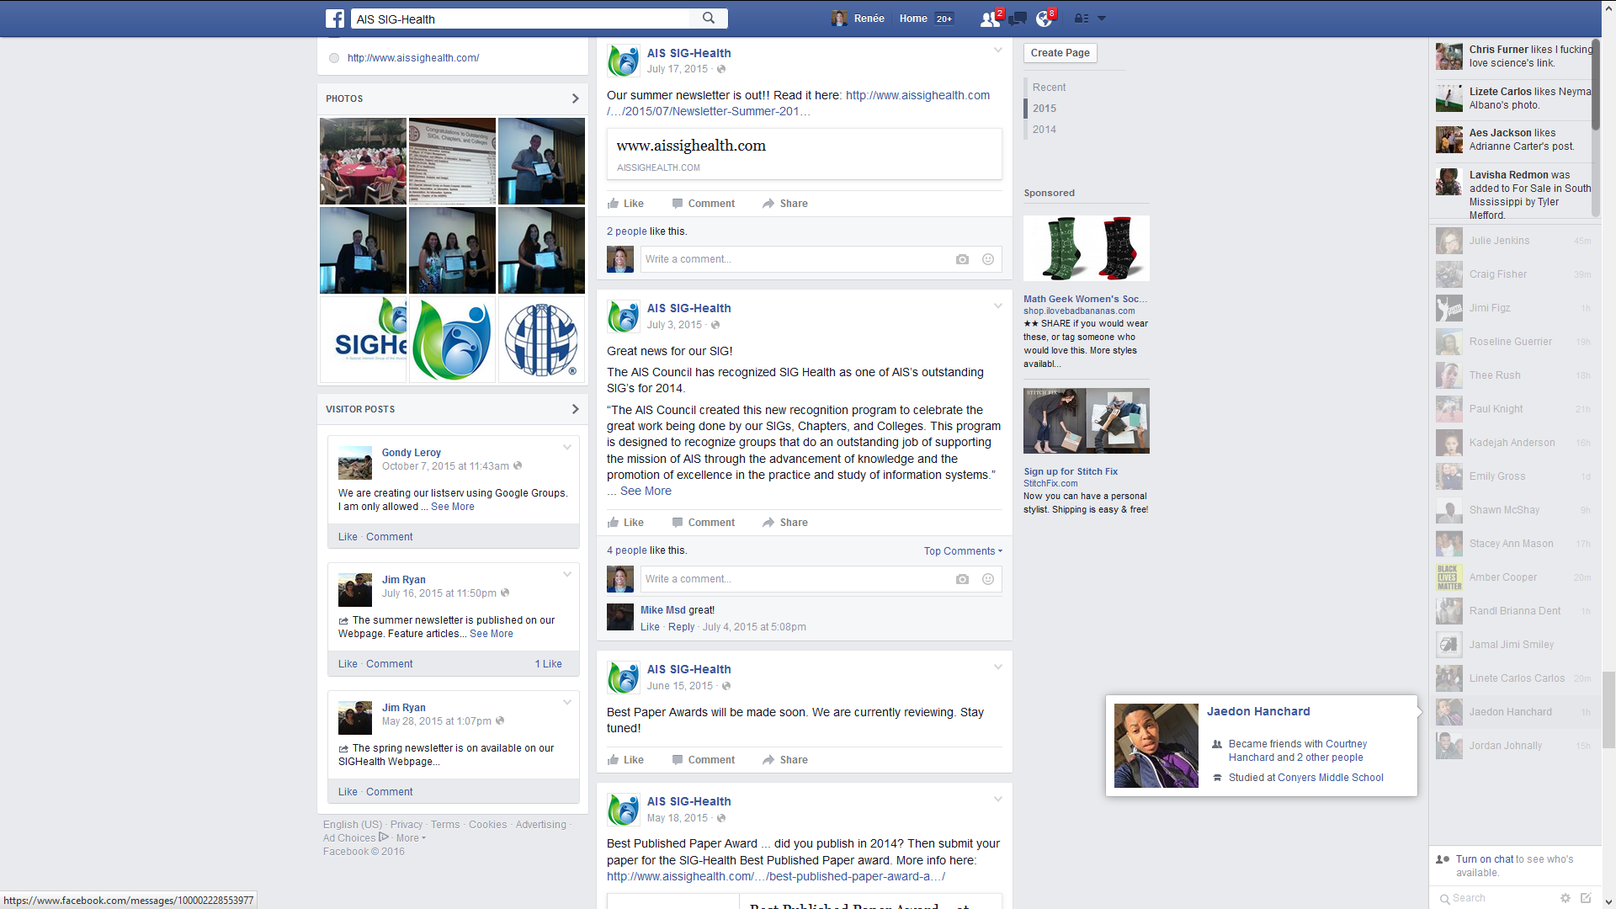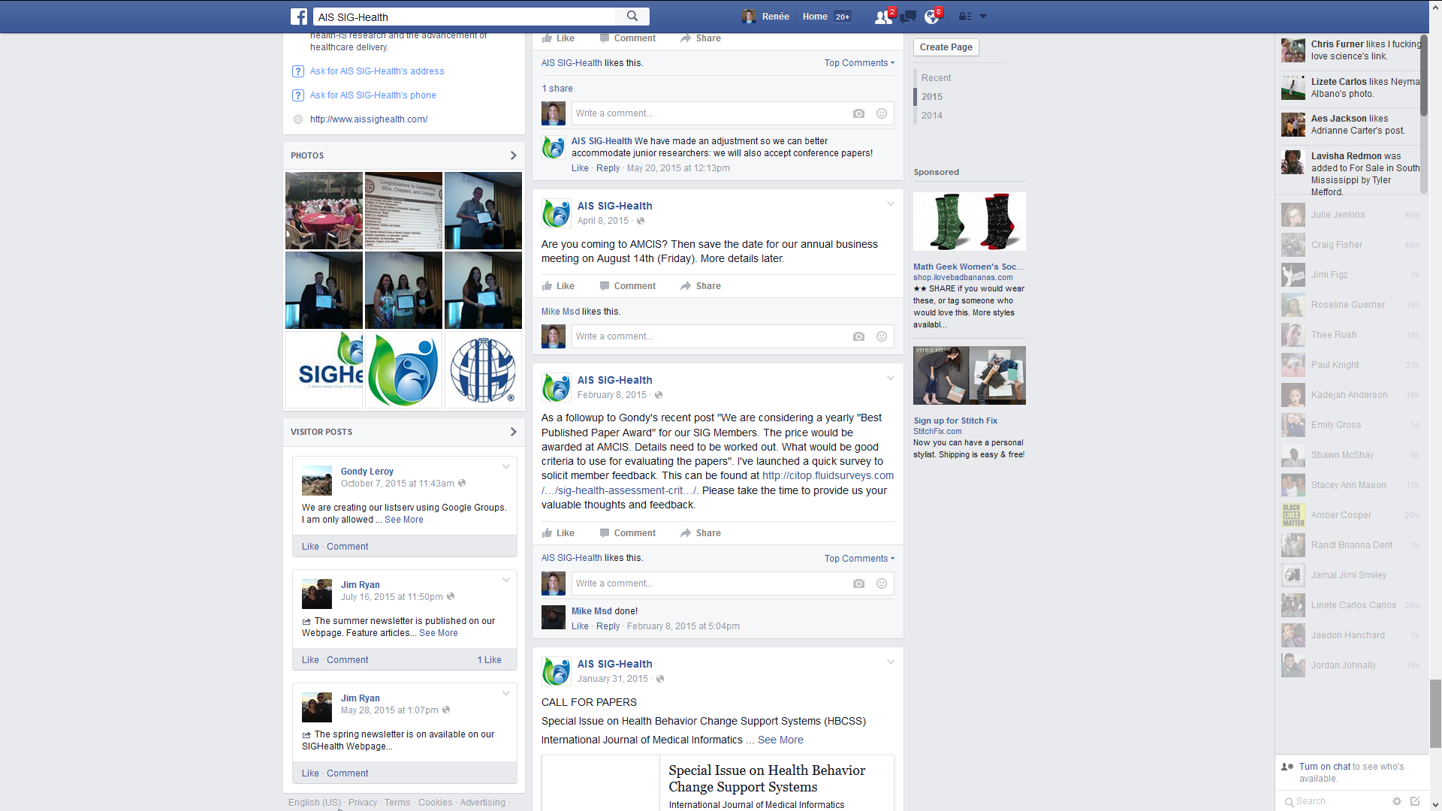
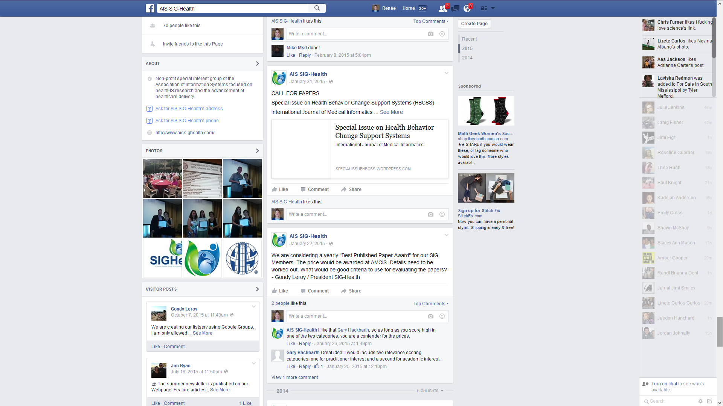
2015 Twitter Tweets

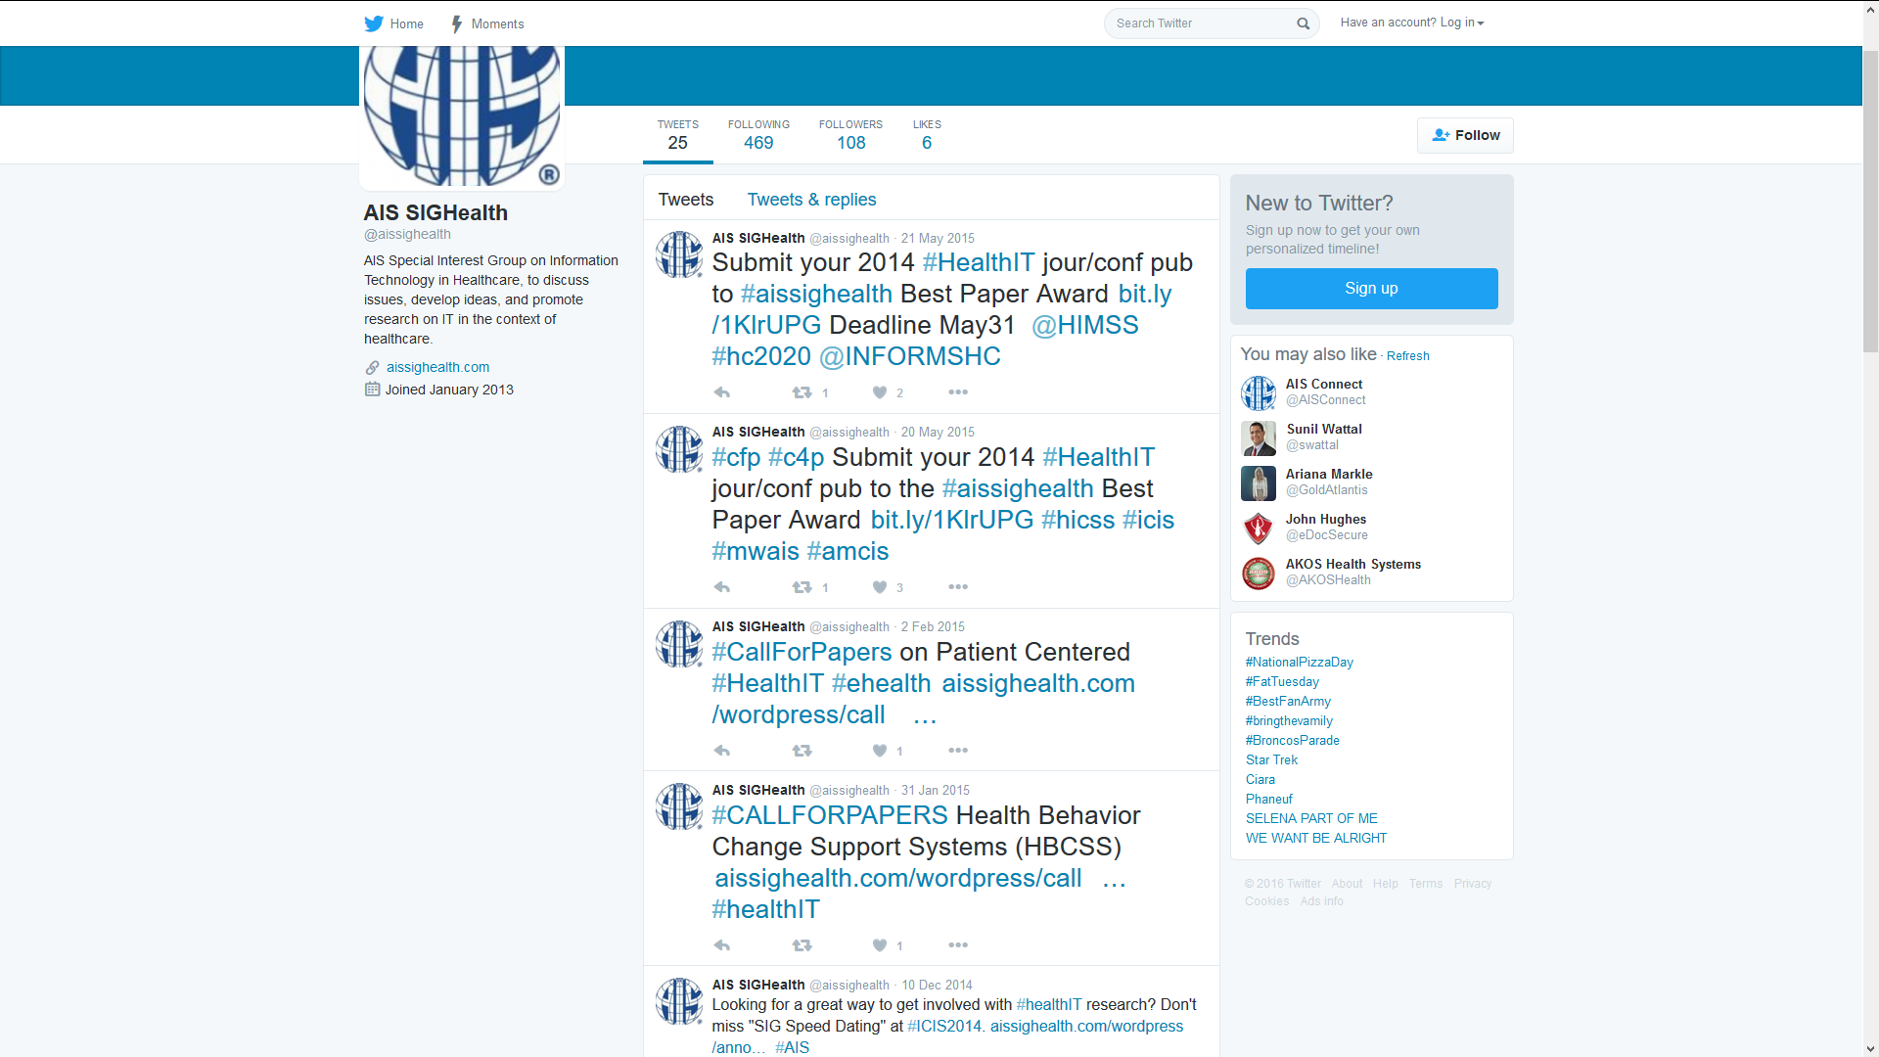

2014 Announcements/Updates on our Website:

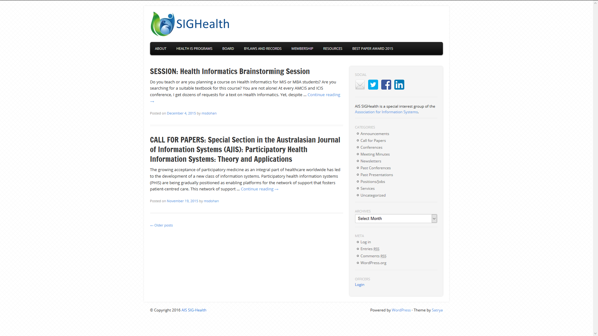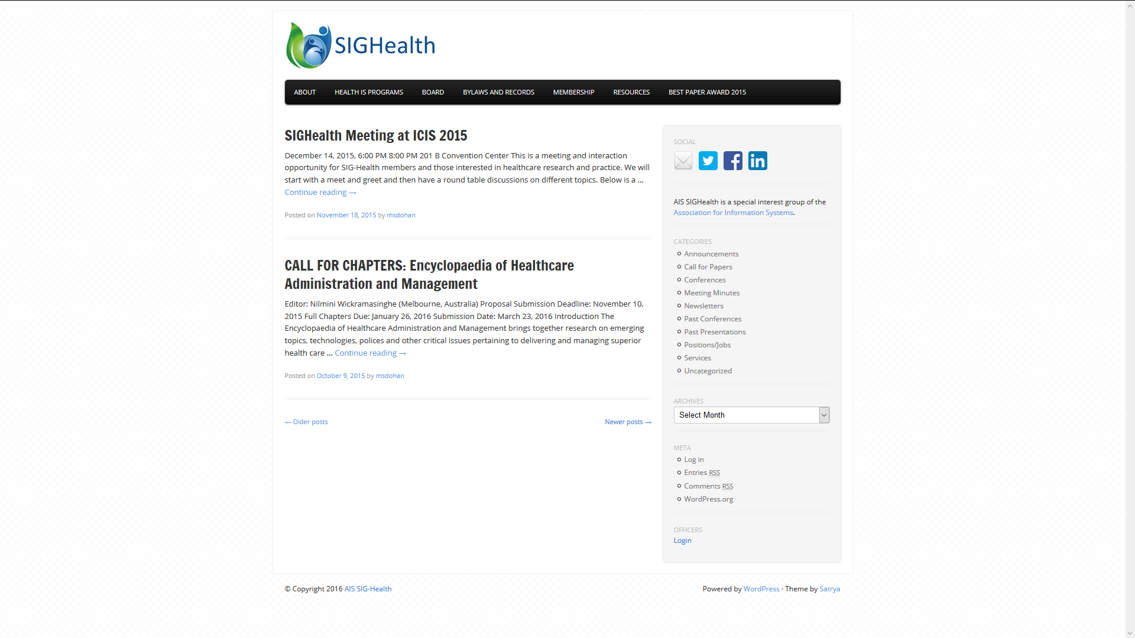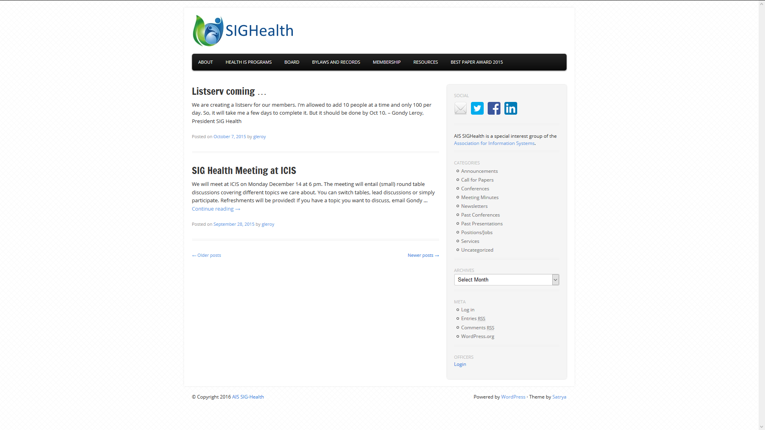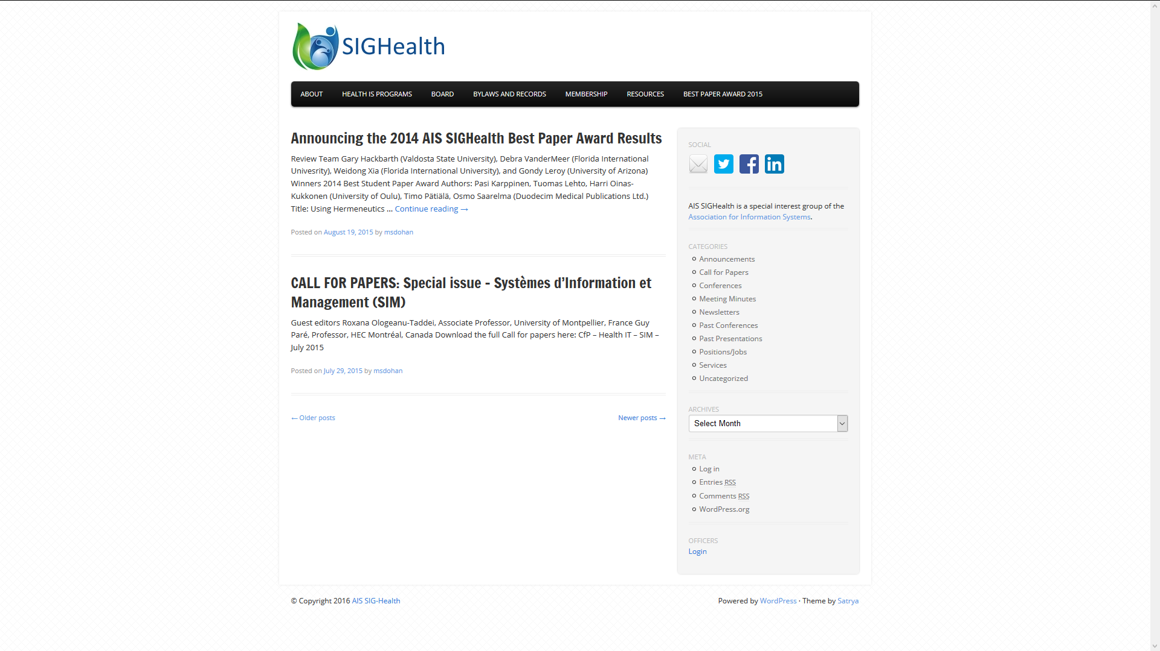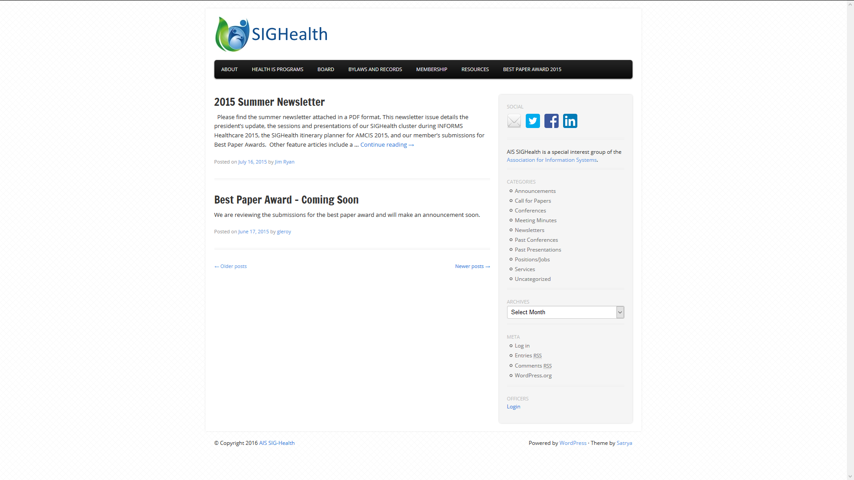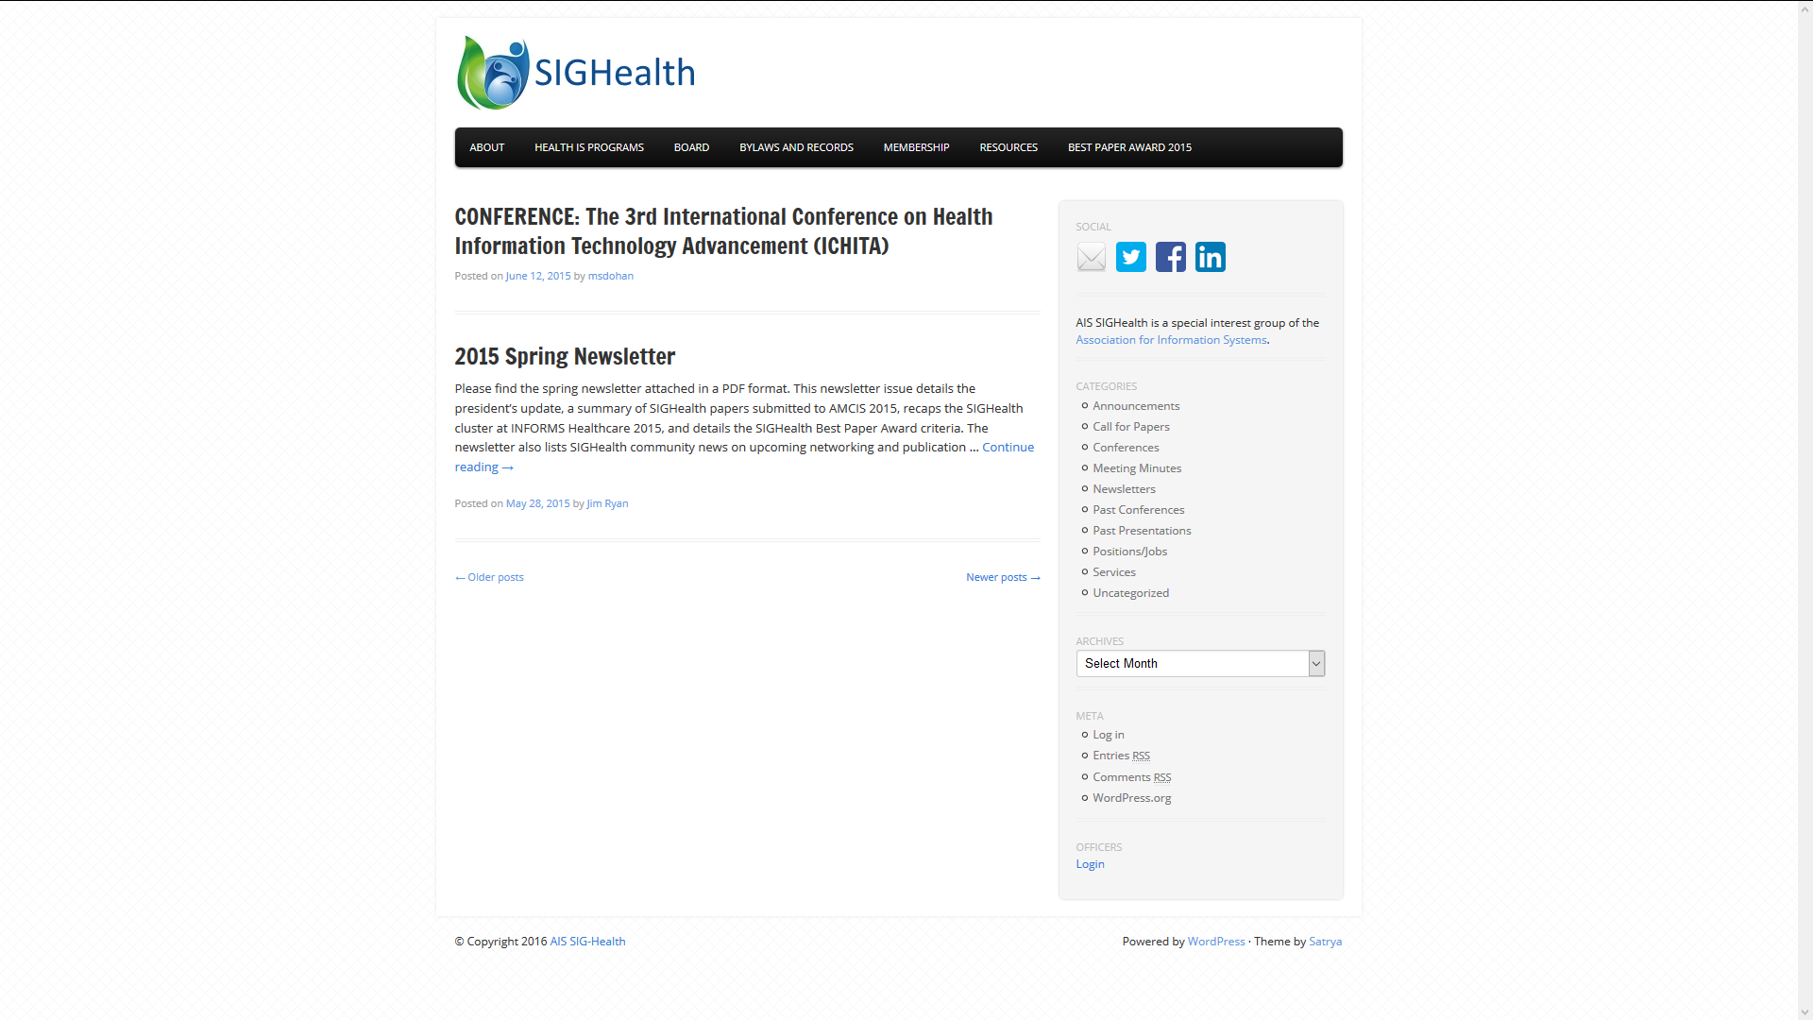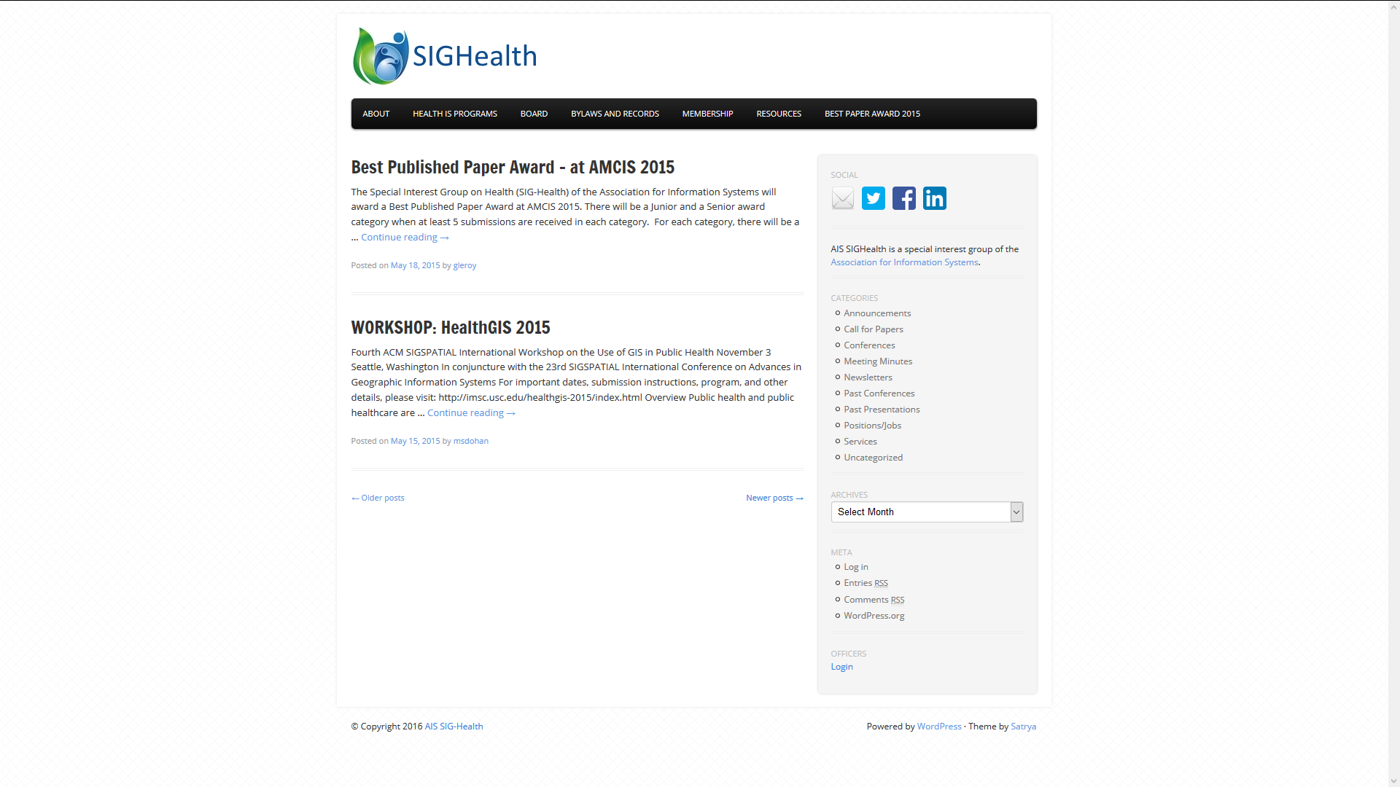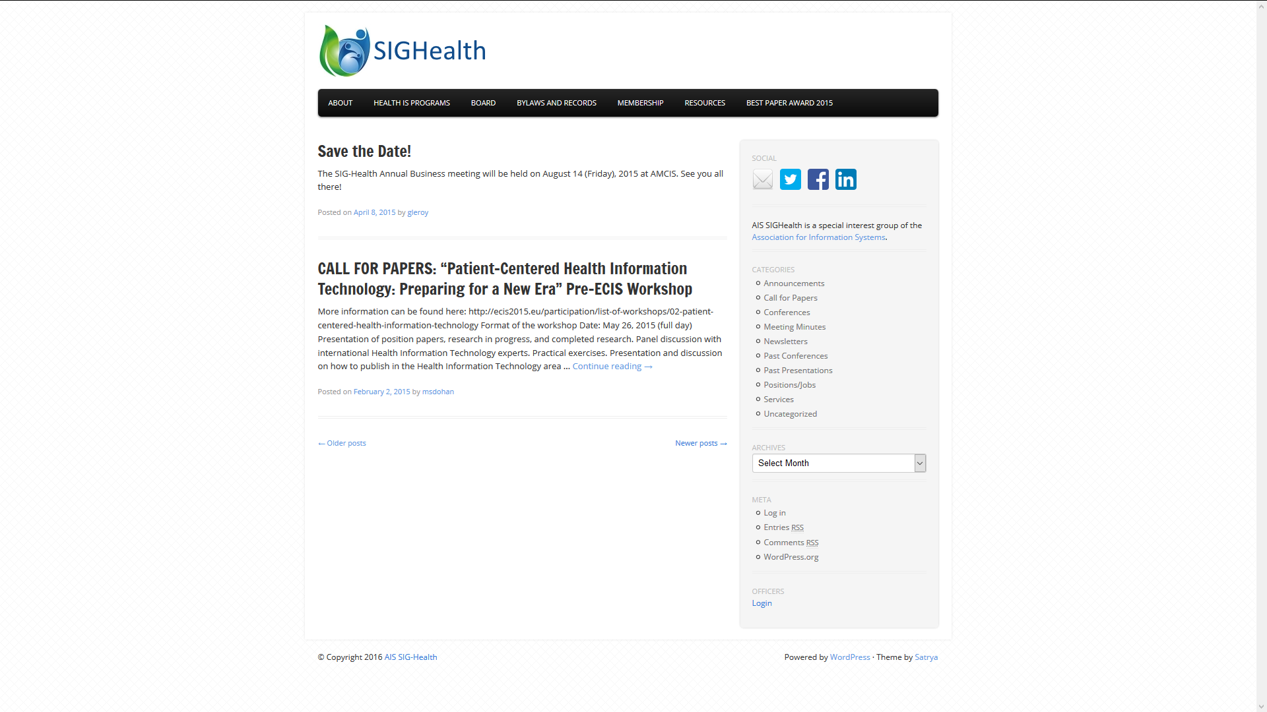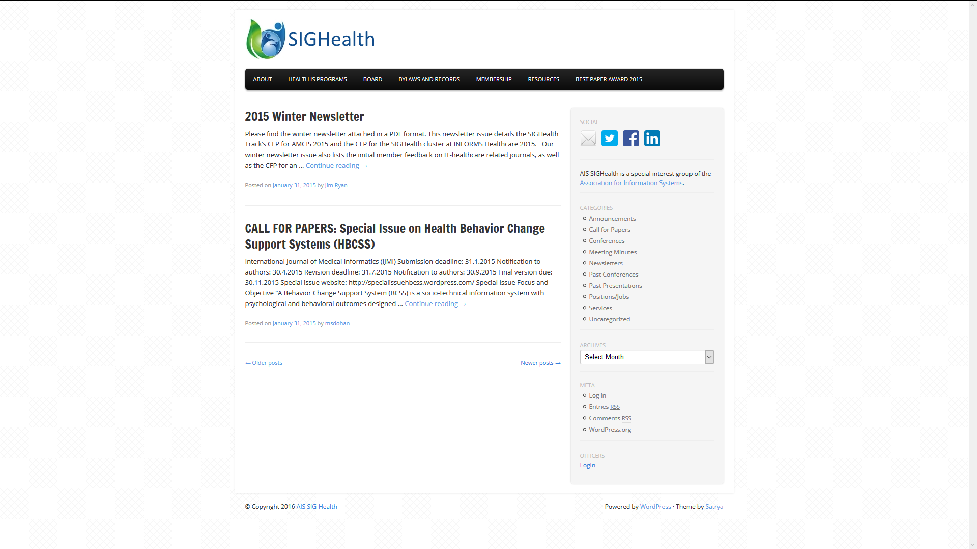

2015 Linked-In Announcements

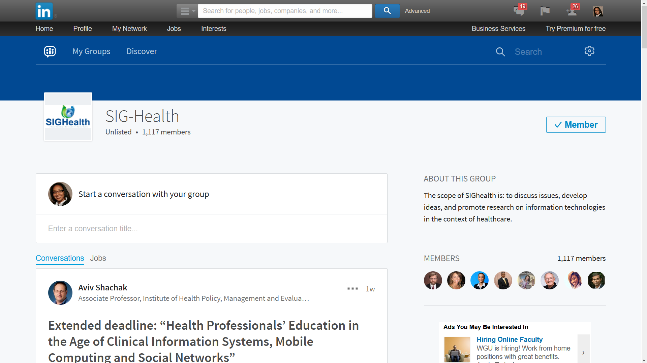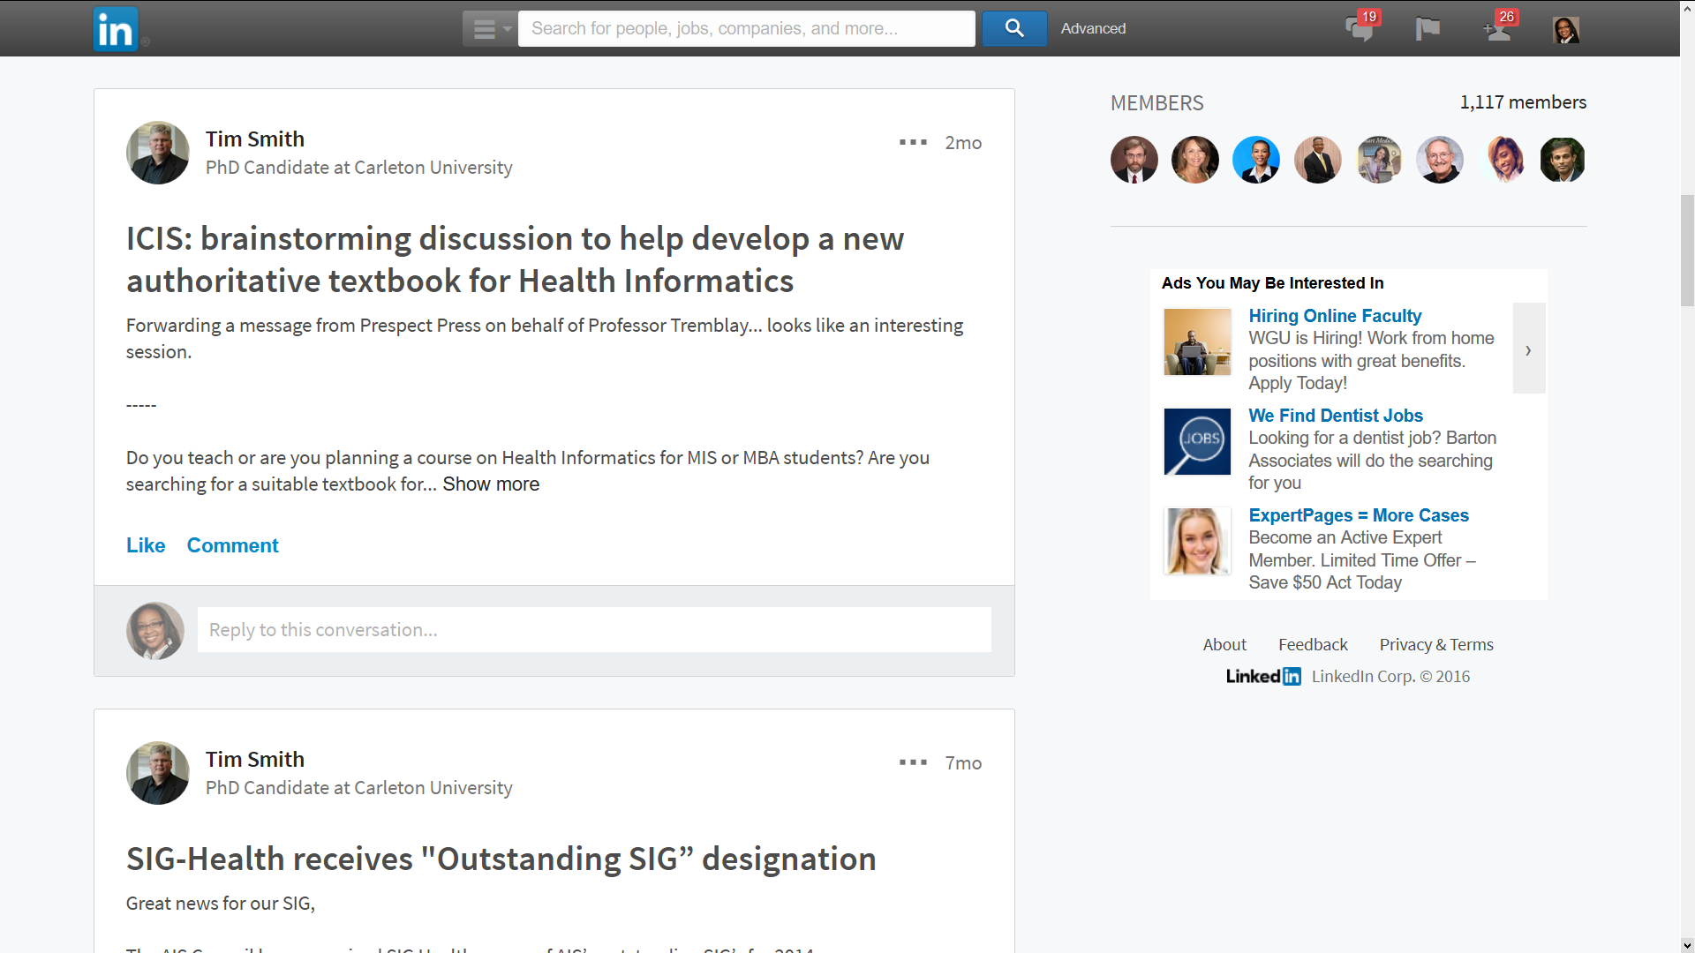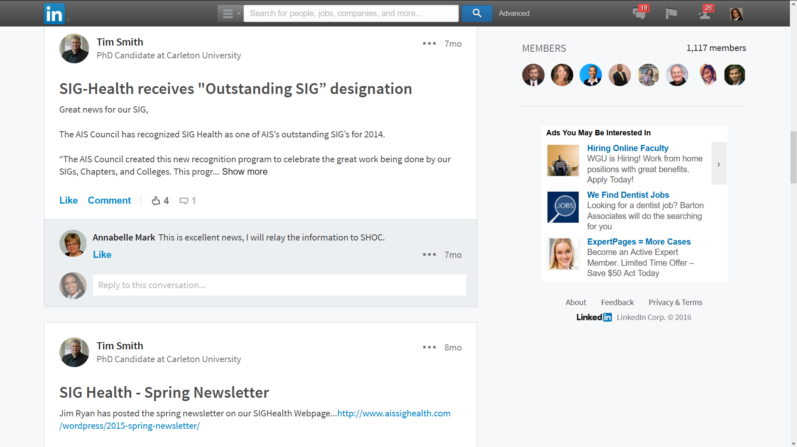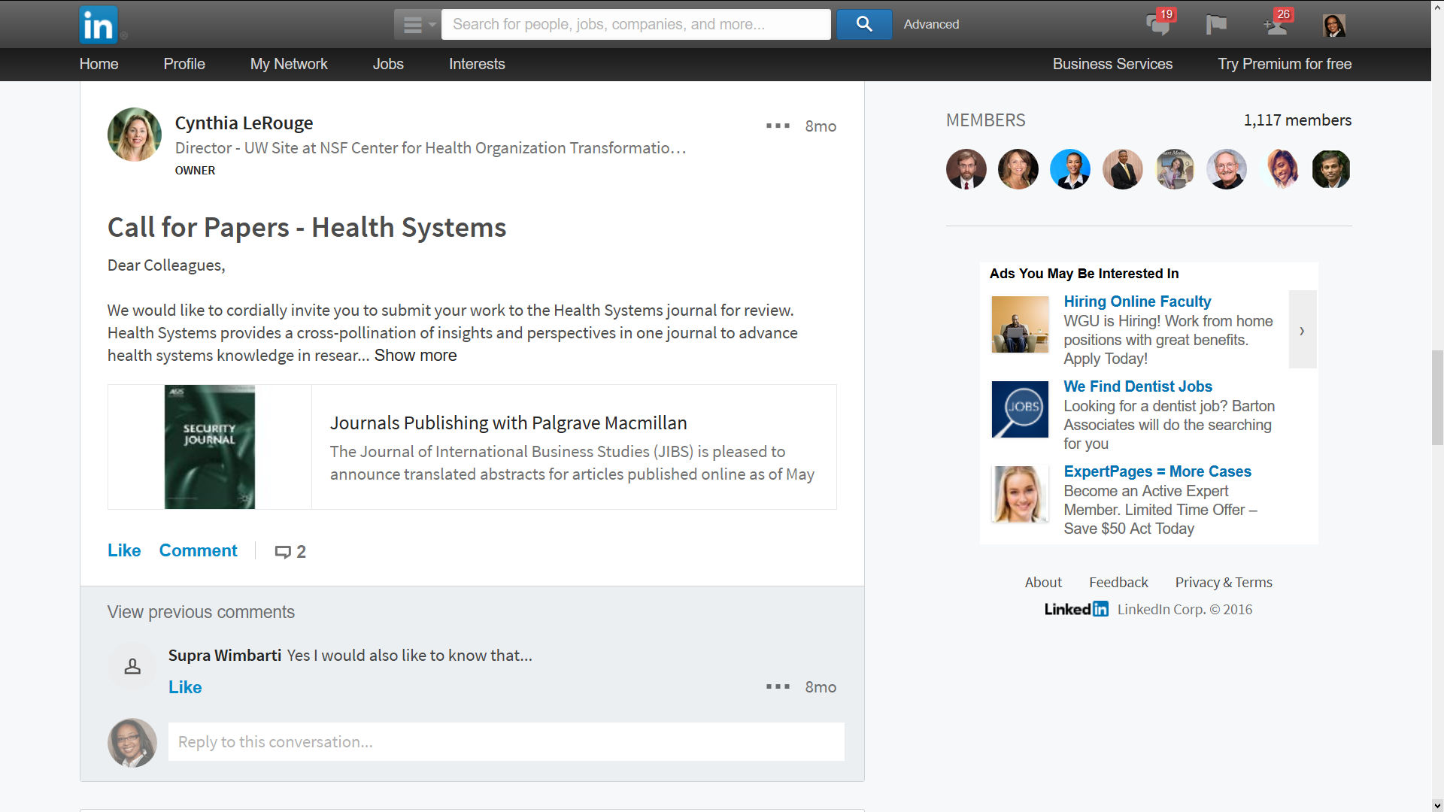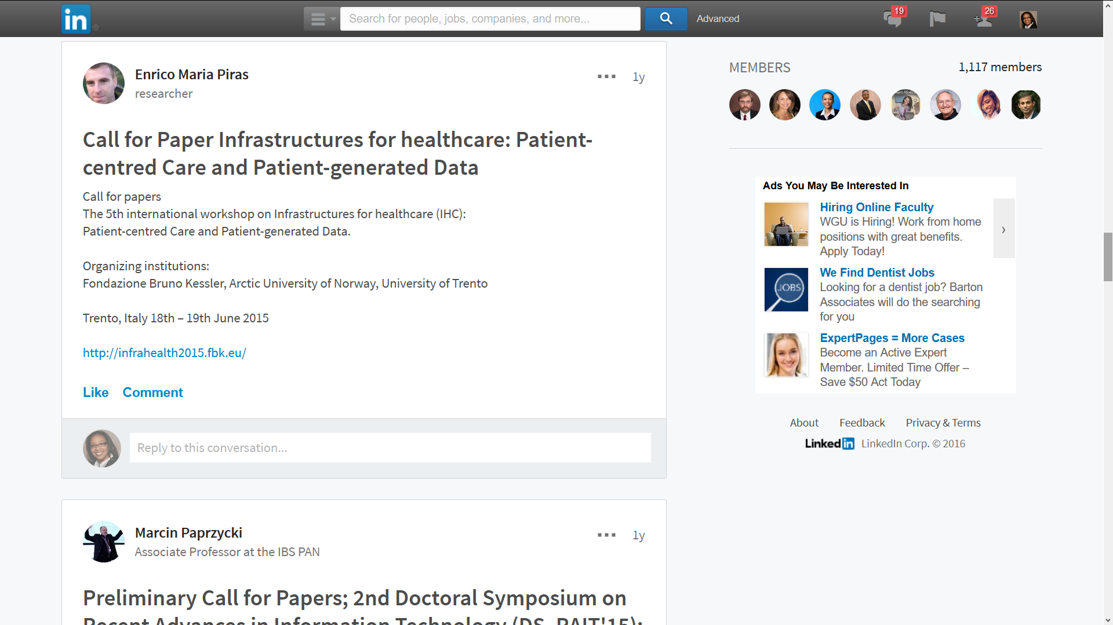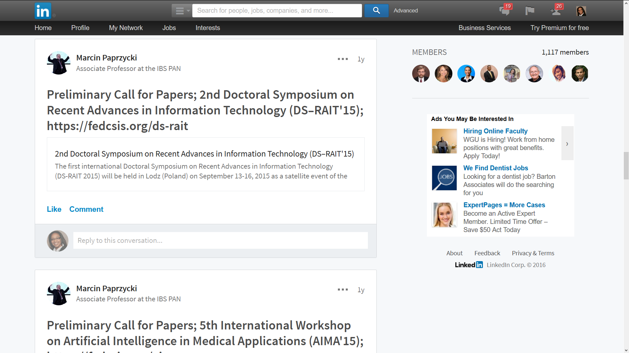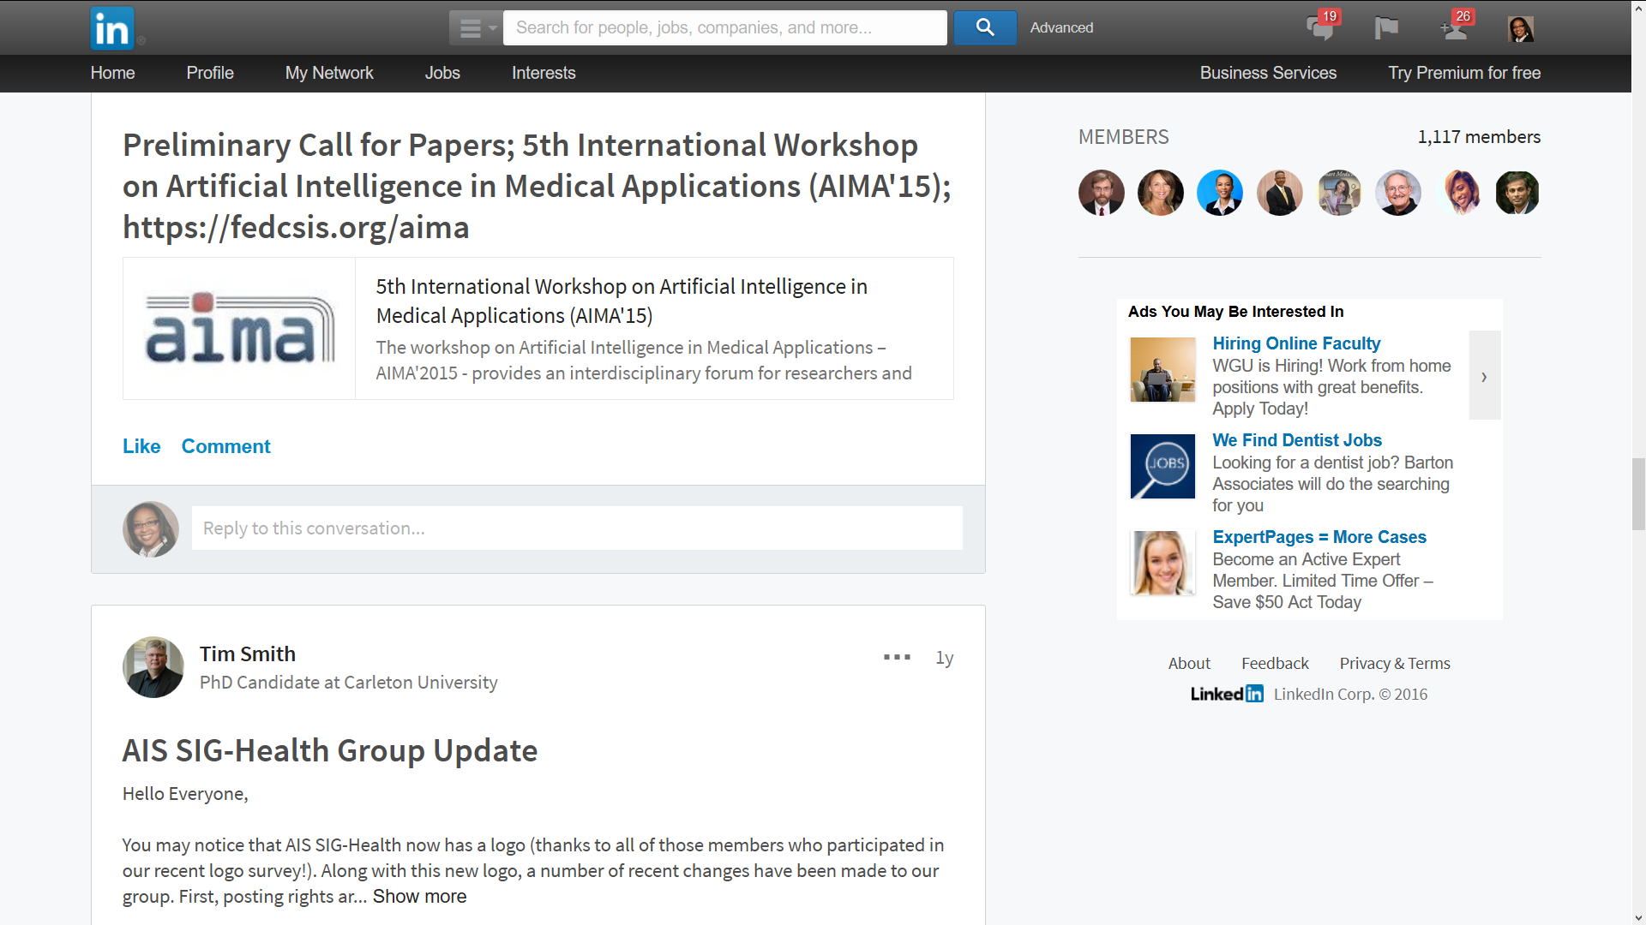

Creation of our own List Serv. Below an overview of the first posts and discussions

